URL :- http://elearningm1.upskills.in/

EPIC - Browse
Story 1 :- Register
Story 2 :- Login
Story 3 :- Logout

1] Test case flow for Register page-

Test Case - 01:-

Test steps :- i. I should open the registration page by clicking on 'Sign Up !'.
Ii. I should fill in the details as per test data.
Iii. I should enter the Register button .
Test Data :- i. First name - Swapnil
Ii. Last Name - Pawar
Iii. Email - pswapnil032@gmail.com
Iv. username - pswapnil032
v. pass - Demo@123
vi. Confirm password - Demo@123
vii. phone - 9284733571
Test Result :- The new user should be created.

Snapshots :-
1.
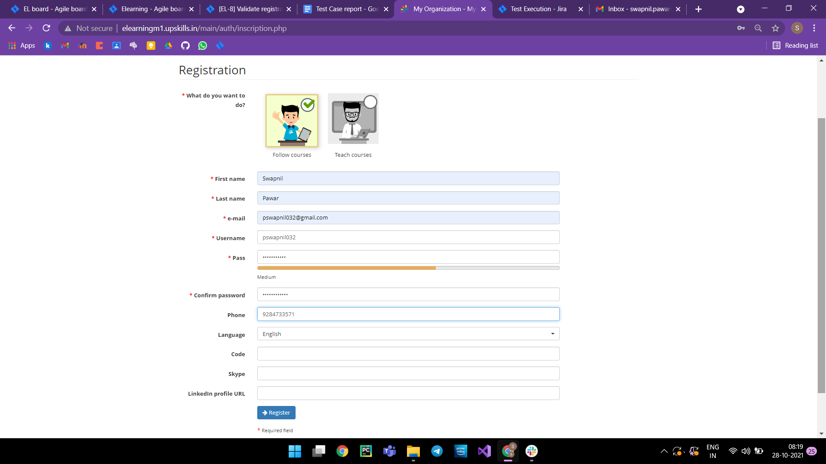
2.
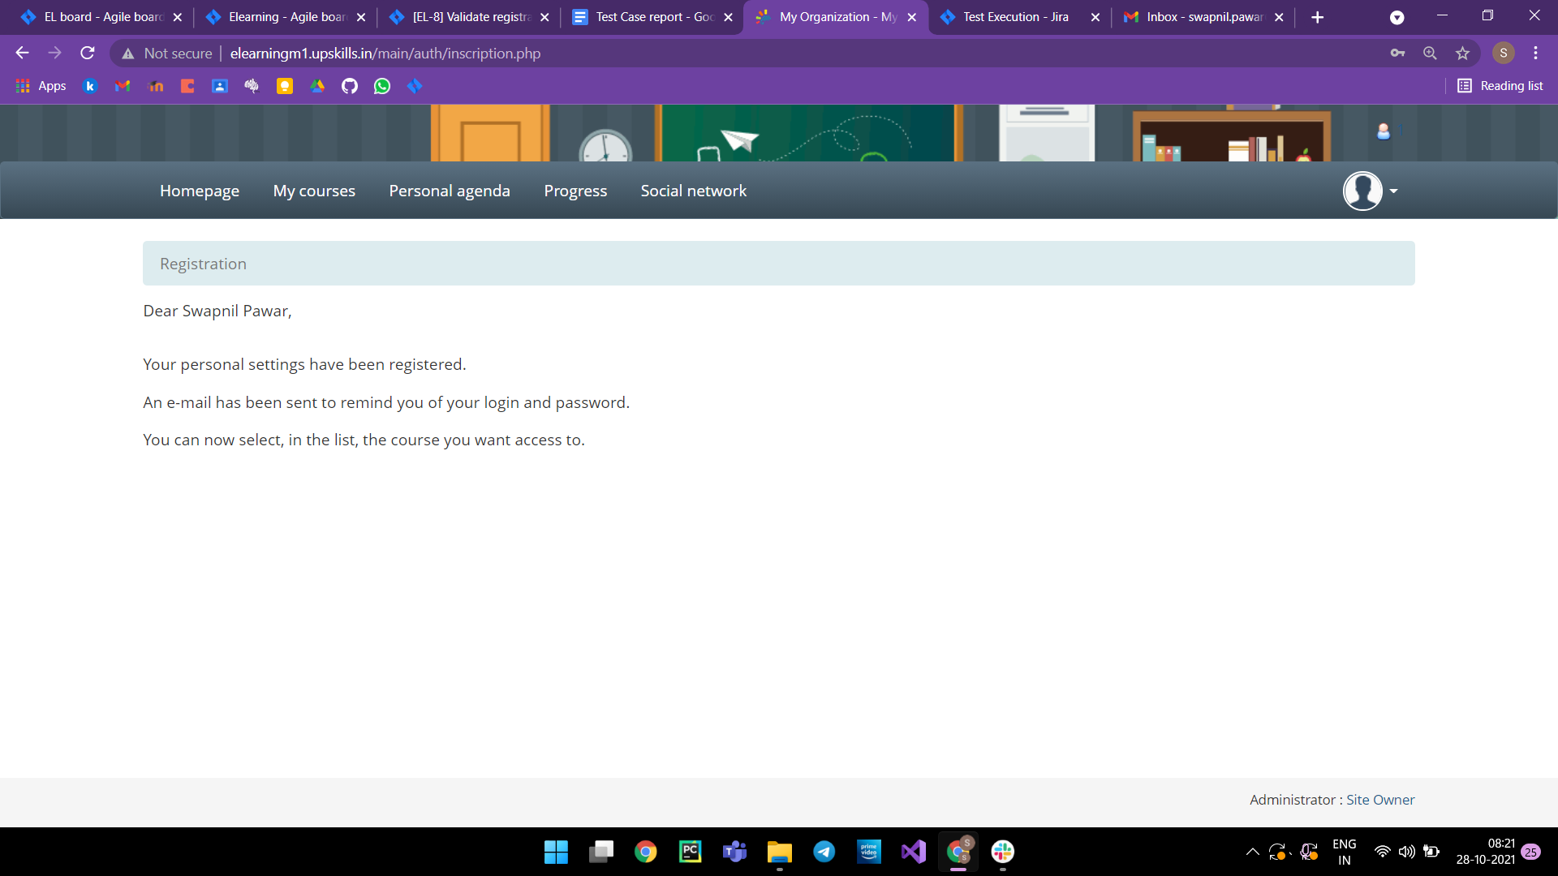
Test Case - 02:-

Test steps :- i. I should open the registration page by clicking on 'Sign Up !'.
Ii. I should fill in the details as per test data.
Iii. I should enter the Register button .
Test Data :- i. First name - DemoUser1
Ii. Last Name - DemoUser1
Iii. Email - DemoUser1@gmail.com
Iv. username - DemoUser1
v. pass - DemoUser1@123
vi. Confirm password - DemoUser1@123
vii. phone - 9997845658
Test Result :- The new user should be created.

Snapshots :-
1.
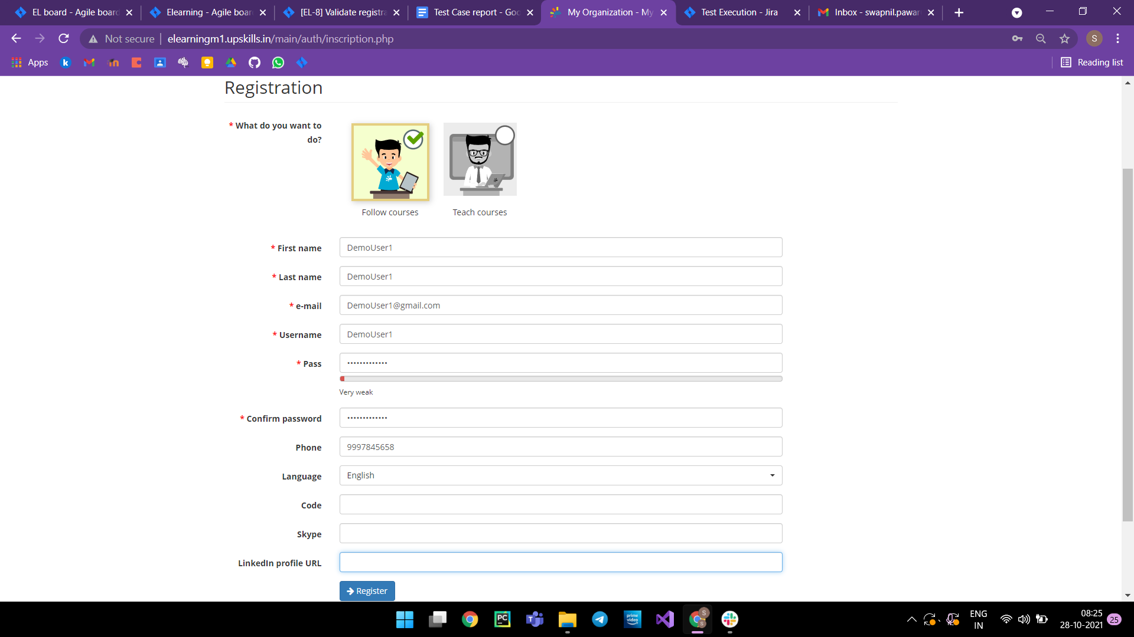

2.
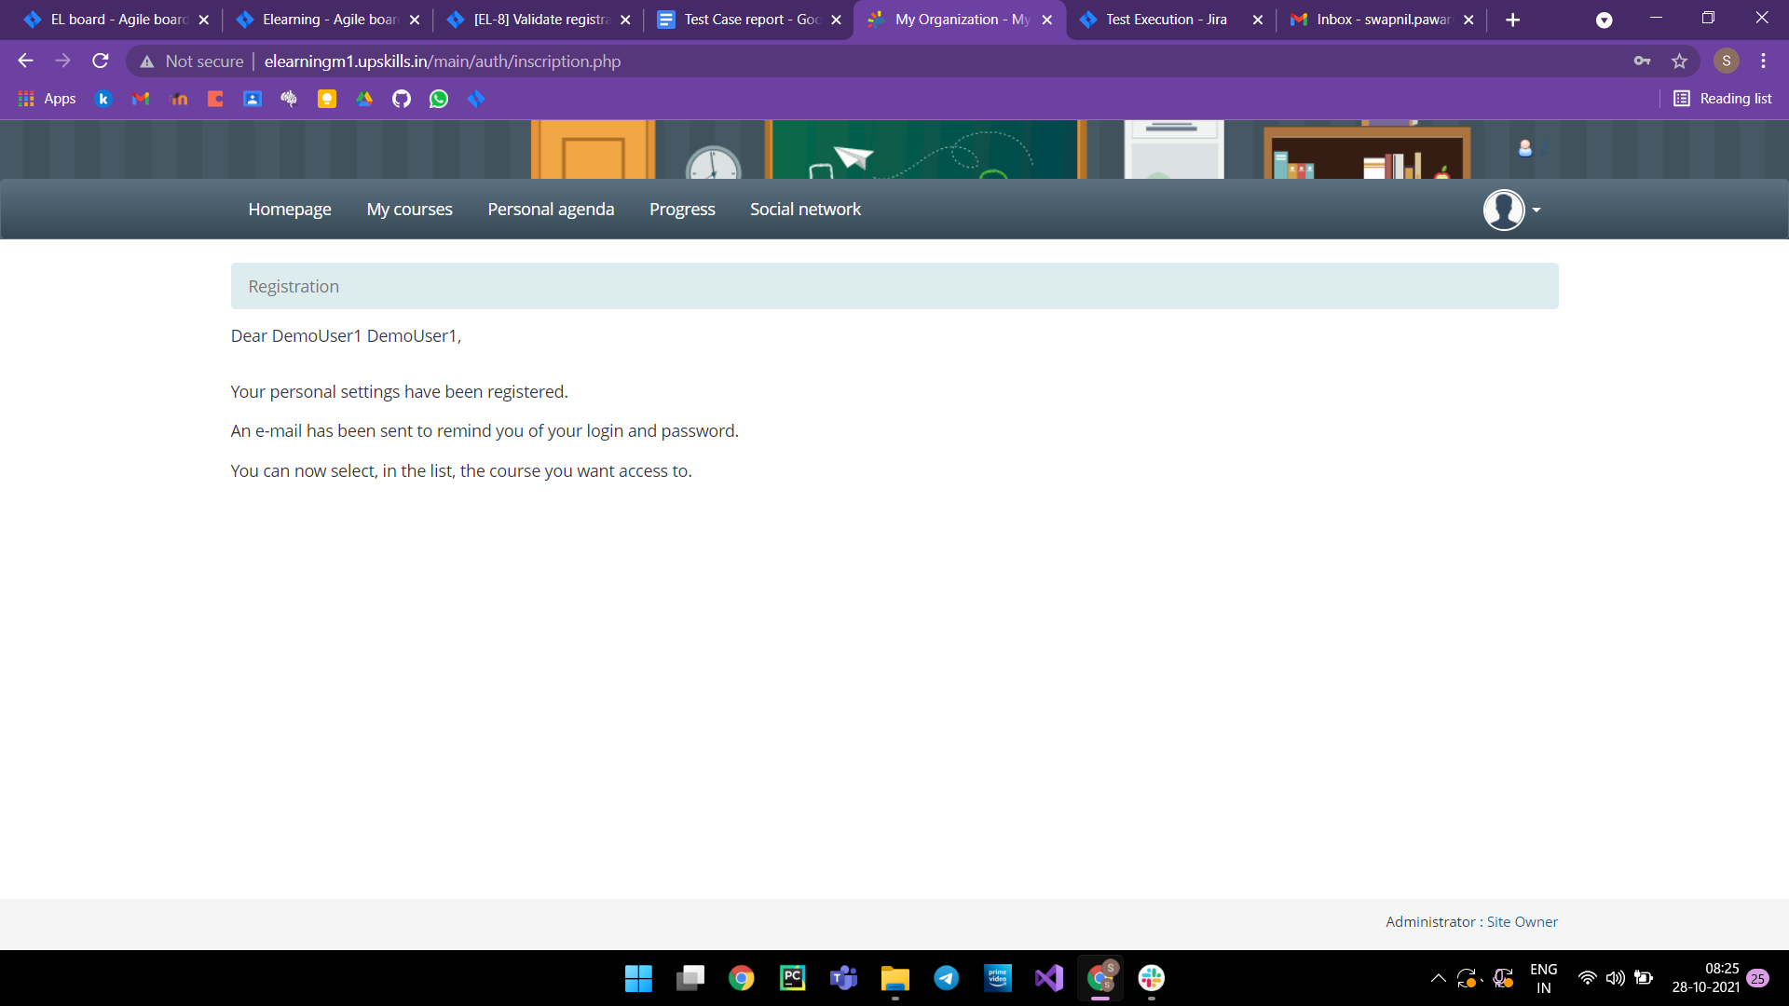

Test Case - 03:-

Test steps :- i. I should open the registration page by clicking on 'Sign Up !'.
Ii. I should fill in the details as per test data.
Iii. I should enter the Register button .
Test Data :- i. First name - DemoUser2
Ii. Last Name - DemoUser2
Iii. Email - DemoUser2@
Iv. username - DemoUser2
v. pass - DemoUser2@123
vi. Confirm password - DemoUser2@123
vii. phone - 9997abc5658
Test Result :- The new user should not be created due to improper email ID.

Snapshots :-
1.
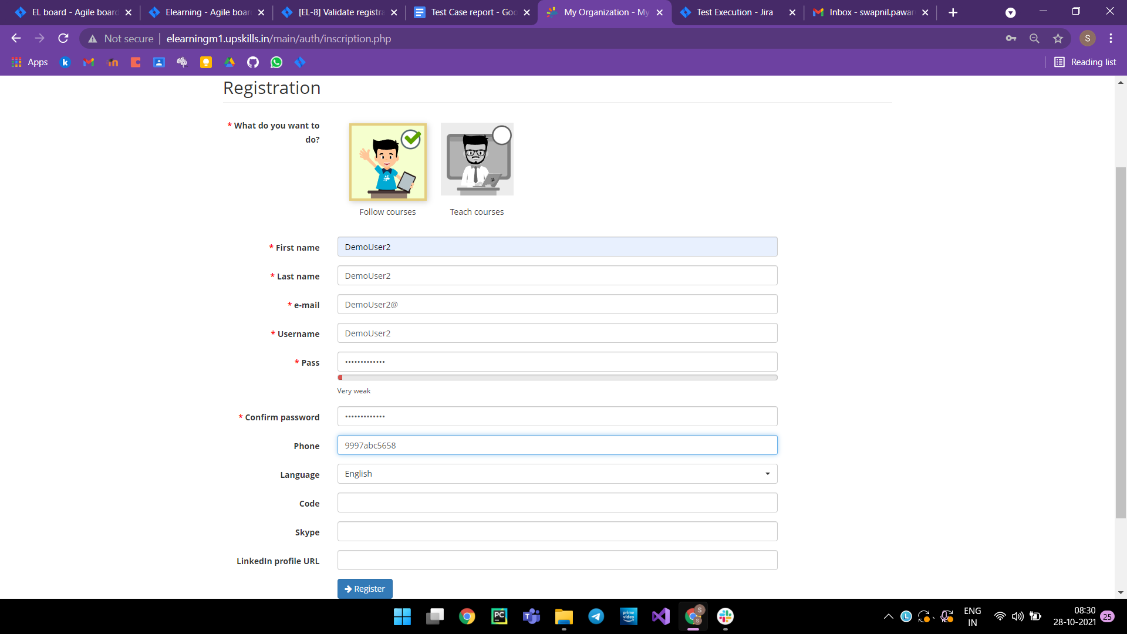

2.
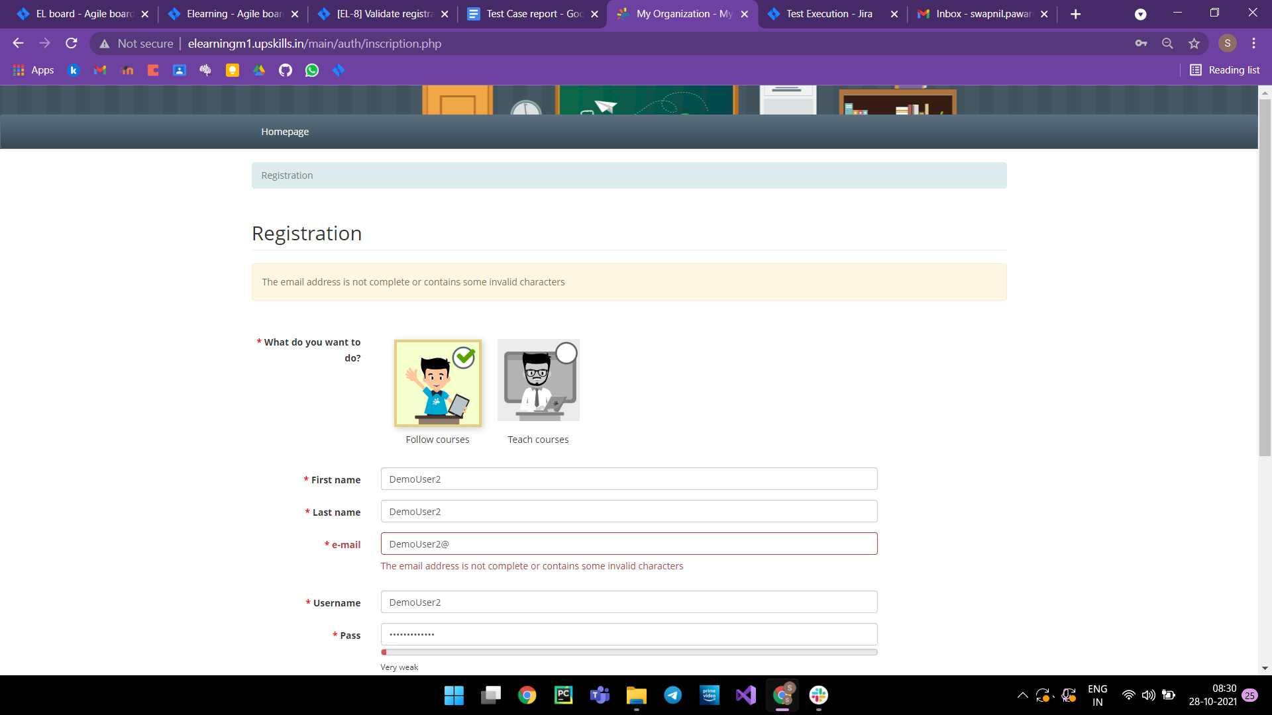

Test Case - 04:-

Test steps :- i. I should open the registration page by clicking on 'Sign Up !'.
Ii. I should fill in the details as per test data.
Iii. I should enter the Register button .
Test Data :- i. First name - DemoUser3
Ii. Last Name - DemoUser3
Iii. Email - DemoUser3@gmail.com
Iv. username - DemoUser3
v. pass - DemoUser3@123
vi. Confirm password - DemoUser2@123
vii. phone - 99976585658
Test Result :- The new user should not be created but to passwords not matching.

Snapshots :-
1.
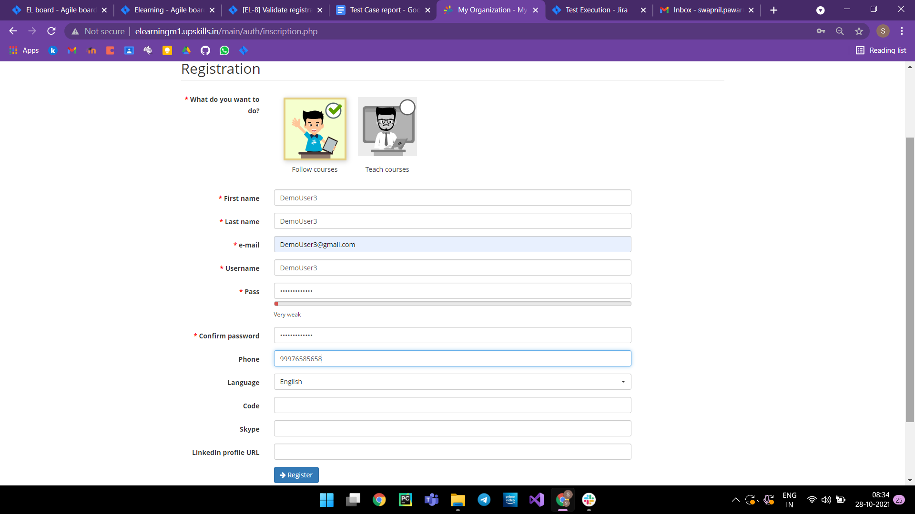

2.
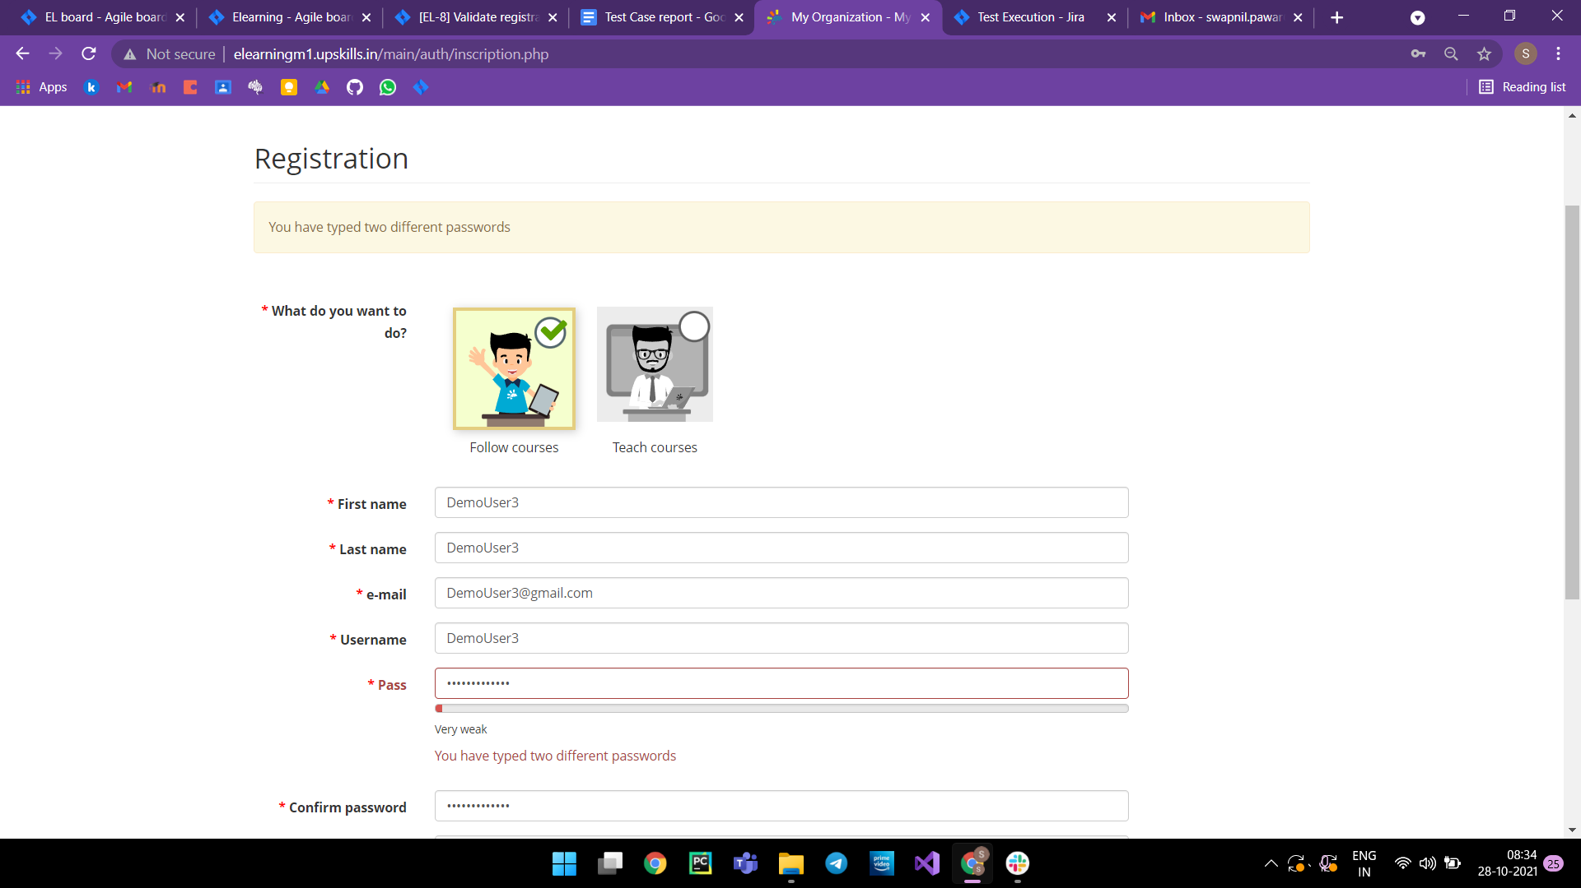

3] Test case flow for Login page-

Test Case - 01:-

Test steps :- i. I should open the login page.
ii. I should fill in the details as per test data.
iii. I should enter the login button.
Test Data :- i. Username :- pswapnil032
Ii. Password :- Demo@123
Test Result :- The My courses page should be open.

Snapshots :-
1.
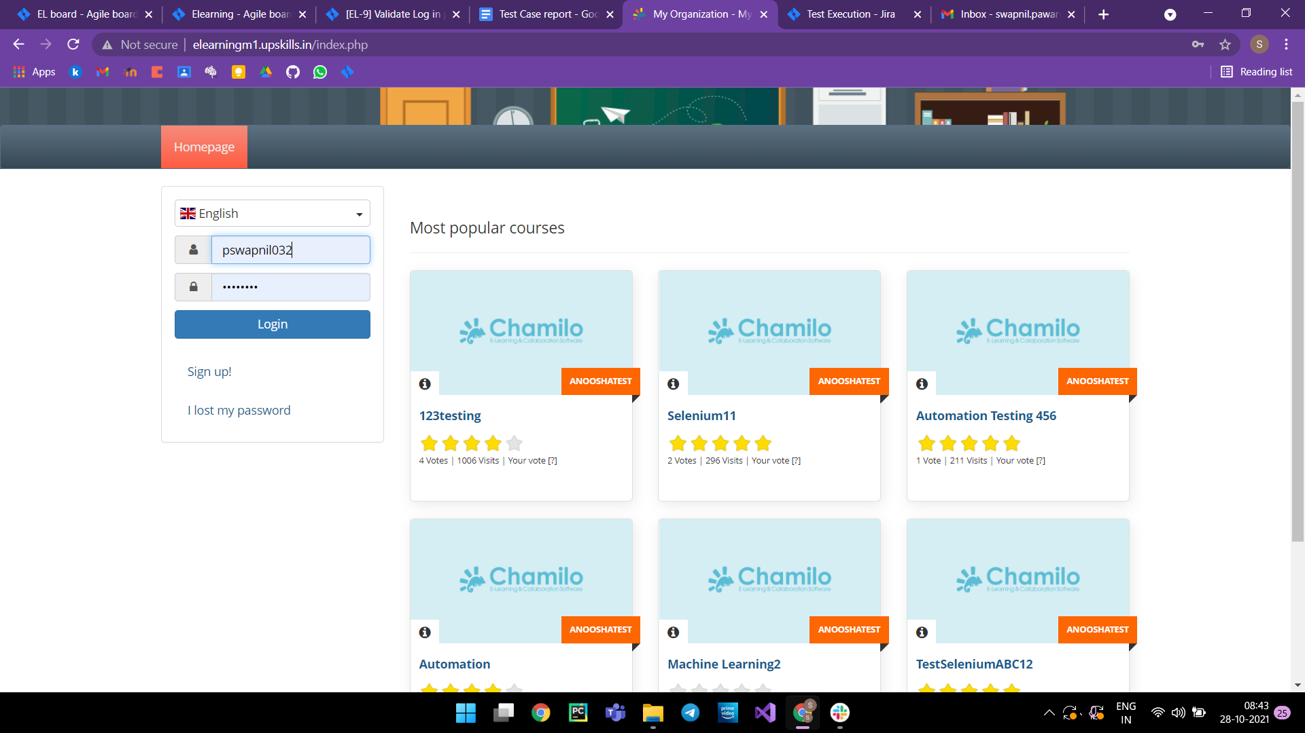

2.
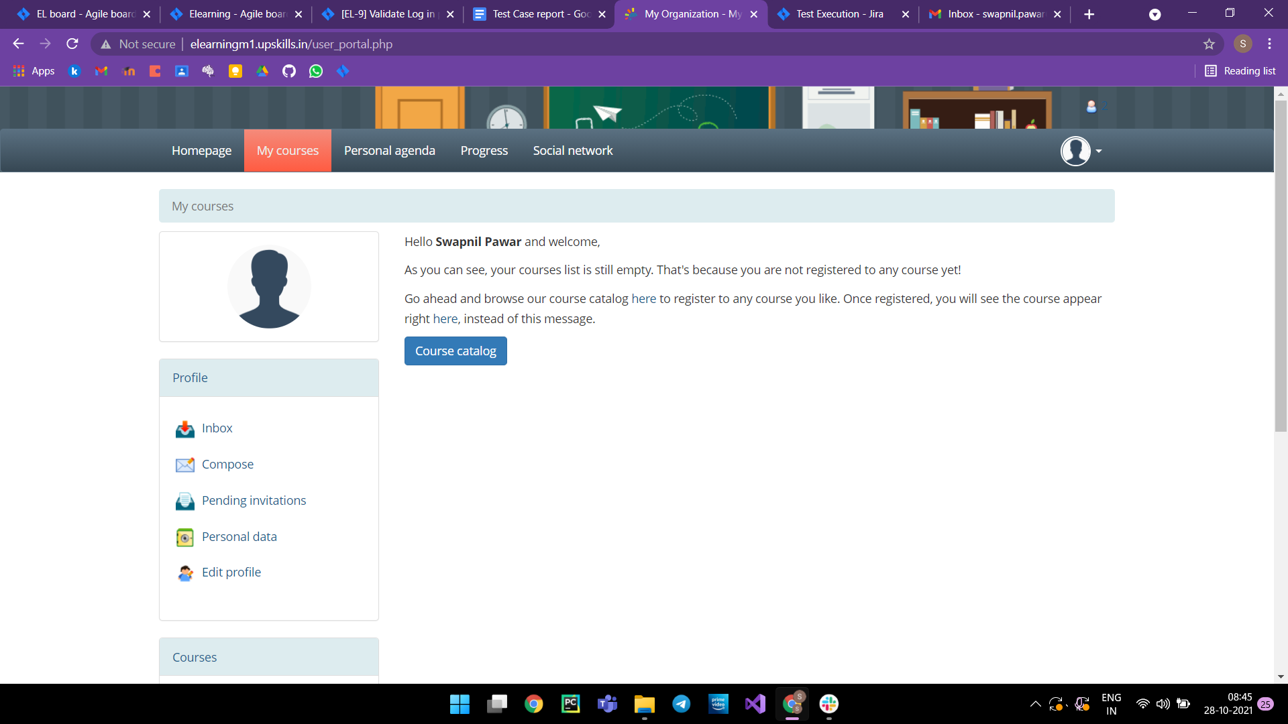

3] Test case flow for Login page-

Test Case - 02:-

Test steps :- i. I should open the login page.
ii. I should fill in the details as per test data.
iii. I should enter the login button.
Test Data :- i. Username :- swapnil7832
Ii. Password :- Demo@123
Test Result :- It should show 'Login failed - incorrect login or password.'

Snapshots :-
1.
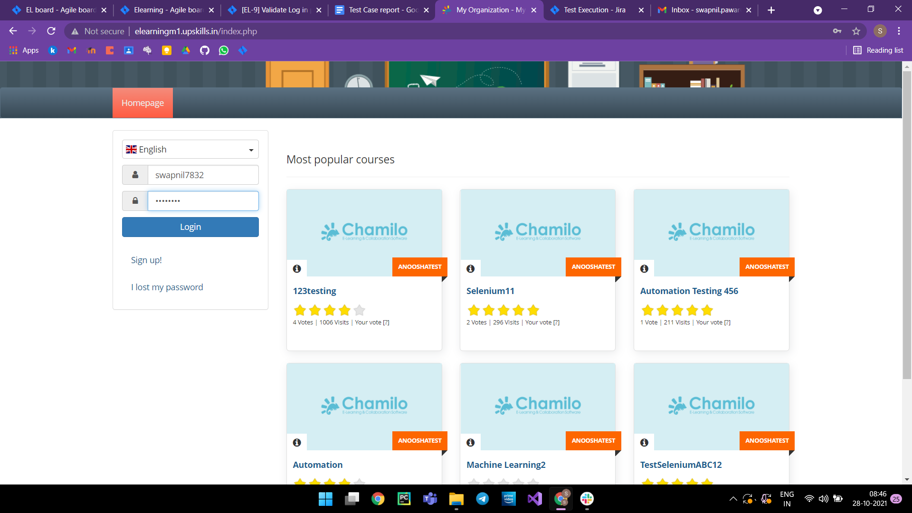

2.
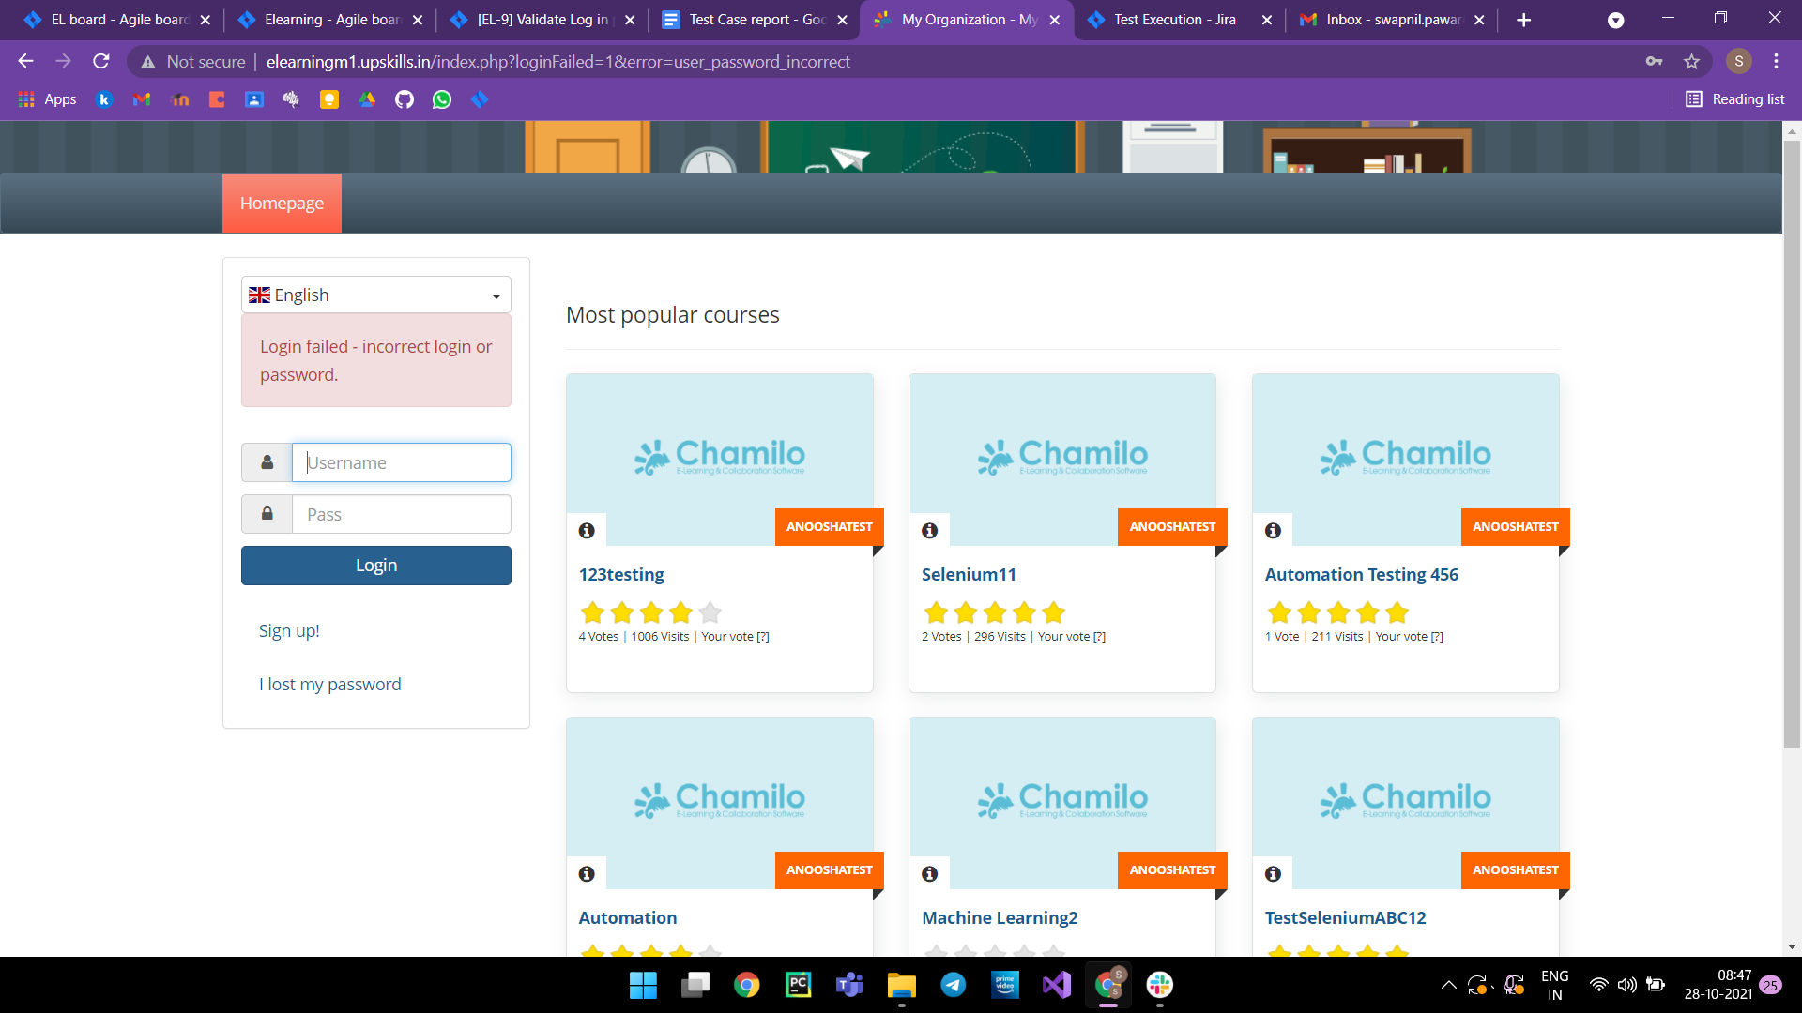

3] Test case flow for Login page-

Test Case - 03:-

Test steps :- i. I should open the login page.
ii. I should enter the login button.
Test Data :-
Test Result :- It should show 'Login failed - incorrect login or password.'

Snapshots :-
1.
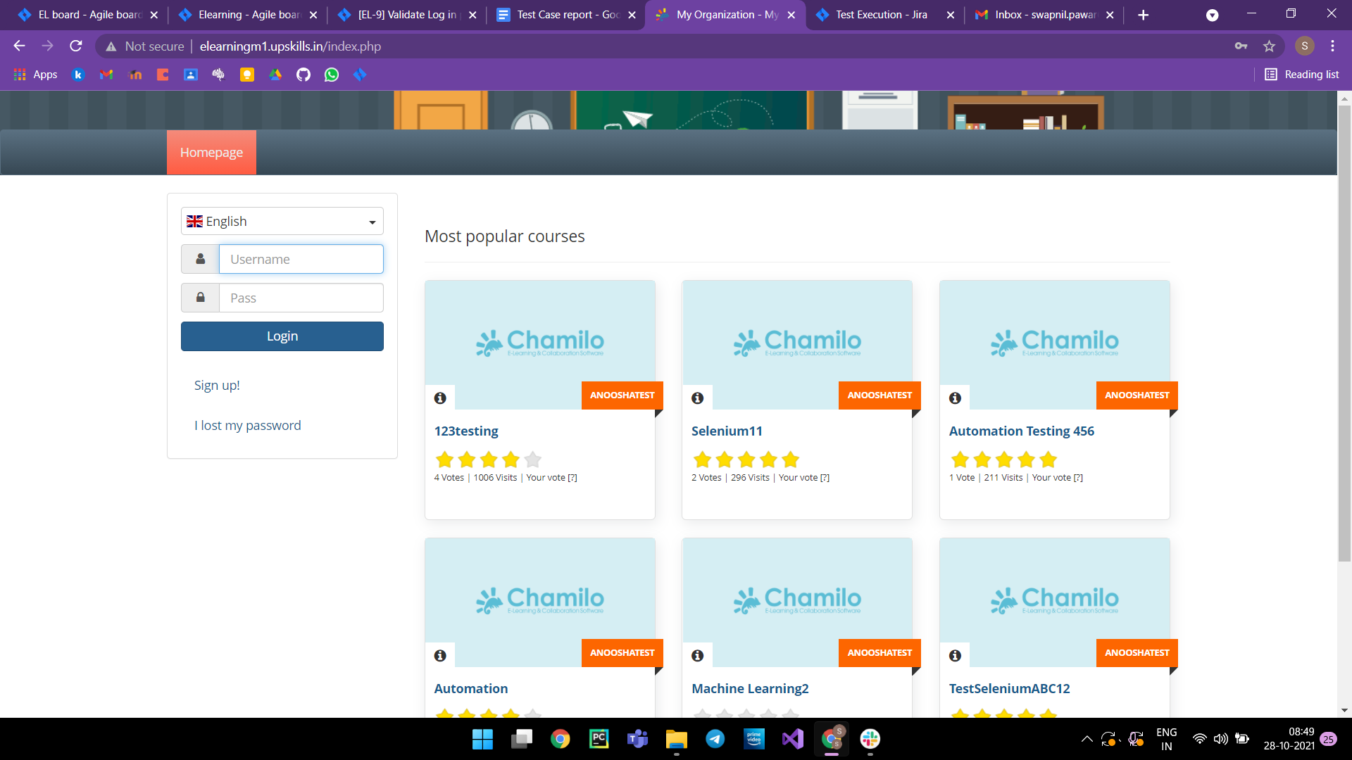
2.


3] Test case flow for Logout page-

Test Case - 01:-

Test steps :- I should click on the profile image icon and then click on logout.
Test Data :-
Test Result :- It should get back to the login page.

Snapshots :-
1.
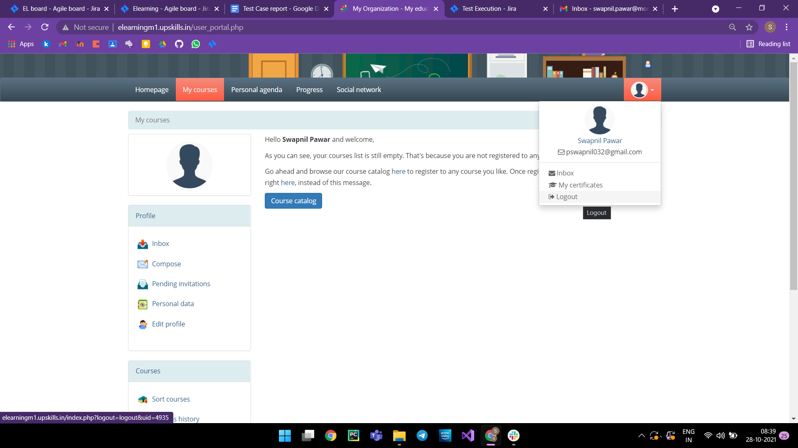

2.
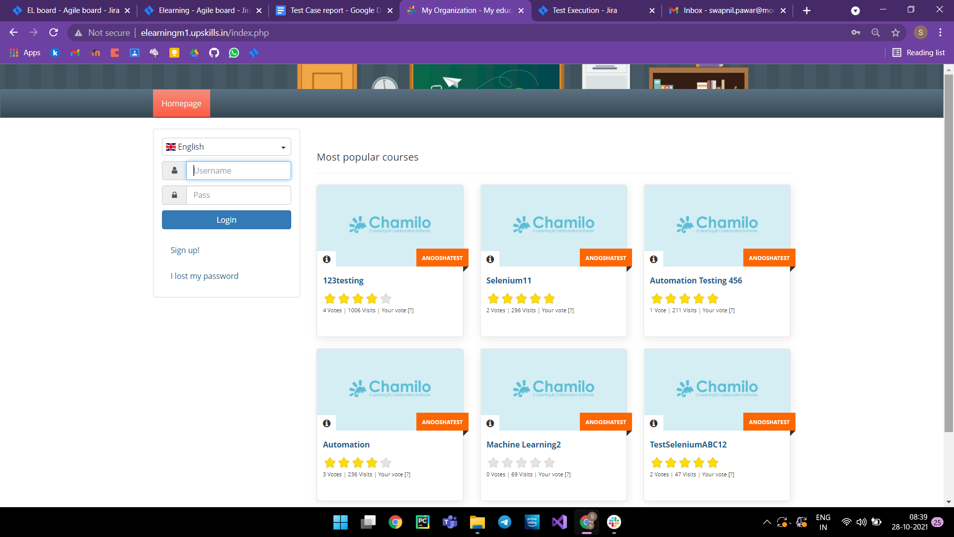

Sprint Board :-
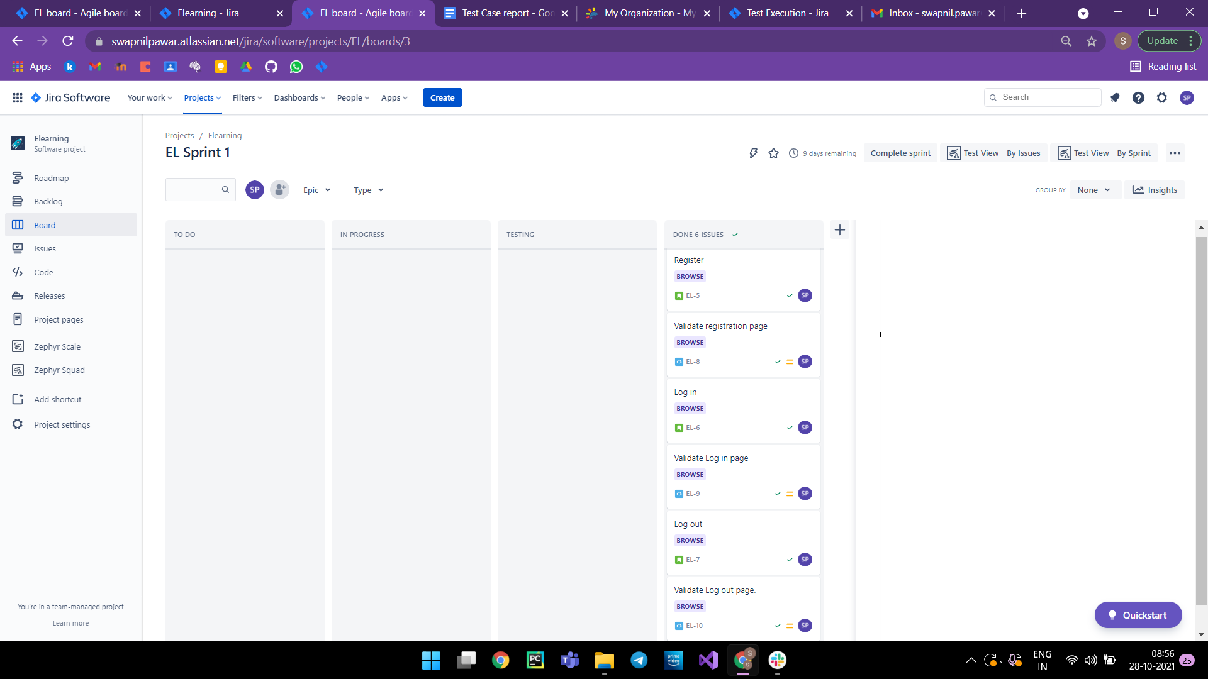

Test Summary:-
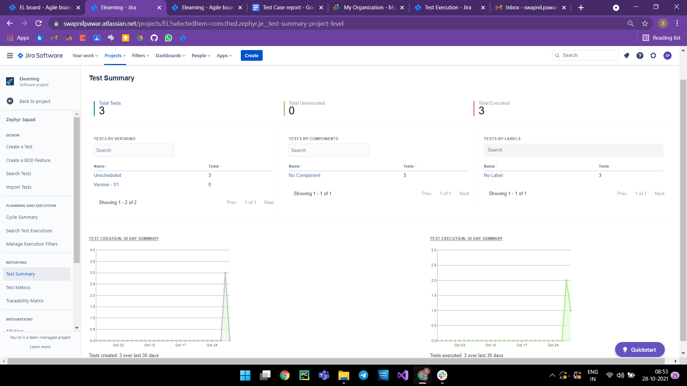

Test Matrix :-
